Name: Aaditi Mahesh Bhalerao.  
Batch: C54  
Roll no.: CS5-78  
PRN: 202401100057

**CISCO CERTIFICATION.**

**1] Python Essential-1**

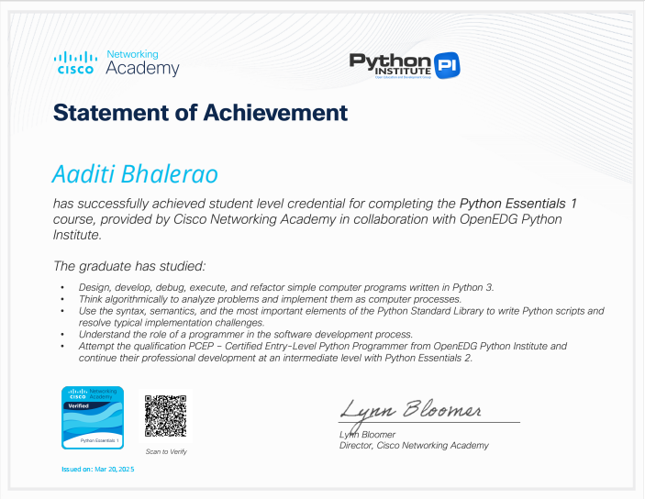

**2] Python Essential-2**

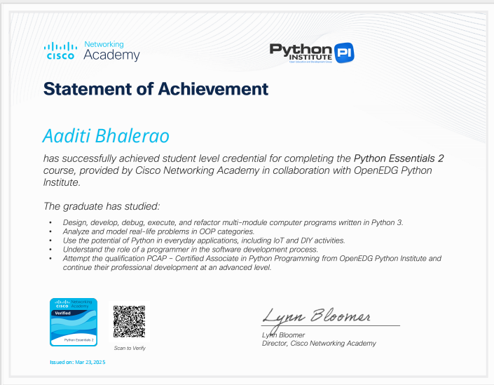

**END**